**ELEVATE LAB “SQL DEVELOPER TASK – 2”**

**EMPLOYEE MANAGEMENT SYSTEM DATABASE**

_____________________________________________________________________________________

**CREATING EMPLOYEES TABLE:**

**CODE:**

CREATE TABLE Employees (

Employee_id INTEGER PRIMARY KEY AUTOINCREMENT,

Name TEXT NOT NULL,

Email TEXT UNIQUE,

Department TEXT,

Salary REAL DEFAULT 30000.00,

Join_date TEXT DEFAULT CURRENT_DATE

);

**OUTPUT:**



**EXPLINATION:** In this code we are creating a values with entities like Name, Email, Department, Salary, Joining date.

**INSERTING VALUES:**

INSERT INTO Employees (name, email, department, salary, join_date)

VALUES ('Shamish Kumar', 'shamish.k@example.com', 'IT', 48000.00, '2023-04-01');

INSERT INTO Employees (name, email, department)

VALUES ('Surya R', 'surya.r@example.com', 'Marketing');

INSERT INTO Employees (name, email, department, salary)

VALUES ('Charan M', 'charan.m@example.com', NULL, 35000.00);

INSERT INTO Employees (name, email)

VALUES ('Raghav Iyer', 'raghav.iyer@example.com');

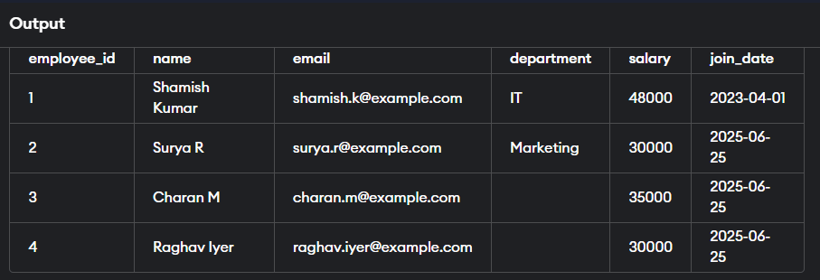

**UPDATING TABLE VALUES:**

UPDATE Employees

SET department = 'Operations'

WHERE name = 'Charan M';

UPDATE Employees

SET salary = 40000.00

WHERE name = 'Surya R';

DELETE FROM Employees

WHERE name = 'Raghav Iyer';

**AFTER UPDATING VALUES:**

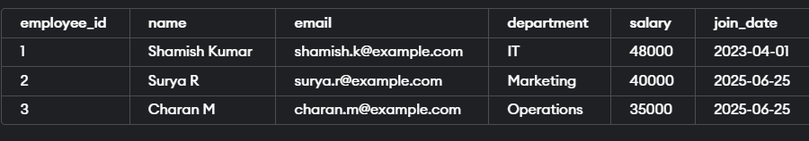

**EXPLINATION:** In this code we had made changes in database using keywords like **“UPDATE, SET, Delete”.**

* INSERT with full data (Shamish)
* INSERT using default values (Surya, Raghav)
* INSERT with NULL values (Charan)
* UPDATE salary or department
* DELETE a specific row using WHERE
* SELECT to view final records

_____________________________________________________________________________________

NAME : Bodavula. Saivenkat

Email: [saivenkat.bodavula@gmail.com](mailto:saivenkat.bodavula@gmail.com)

Github: https://github.com/saivenkat182004